**Assignment 1**

**Name:** J Viswaksena **Roll.No:** AM.EN.U4AIE21035

**1. COLLEGE DATABASE:**

STUDENT (USN, SName, Address, Phone, Gender)

SEMSEC (SSID, Sem, Sec)

CLASS (USN, SSID)

SUBJECT (Subcode, Title, Sem, Credits)

MARKS (USN, Subcode, SSID, Test1, Test2, Test3, Final)

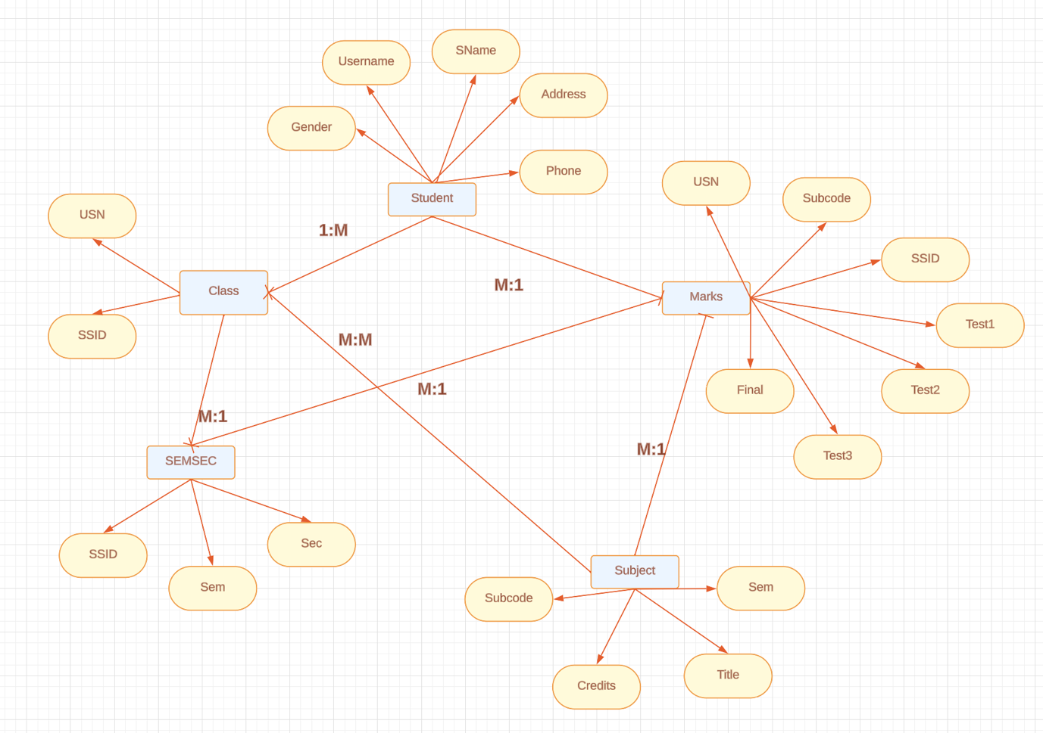

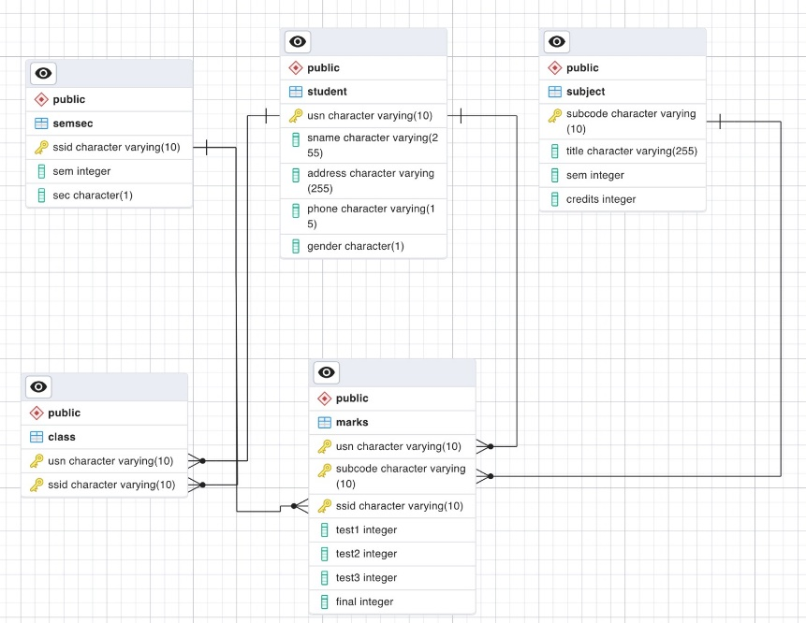

2. COMPANY DATABASE:

EMPLOYEE (SSN, Name, Address, Sex, Salary, SuperSSN, DNo)

DEPARTMENT (DNo, DName, MgrSSN, MgrStartDate)

DLOCATION (DNo,DLoc)

PROJECT (PNo, PName, PLocation, DNo)

WORKS_ON (SSN, PNo, Hours)

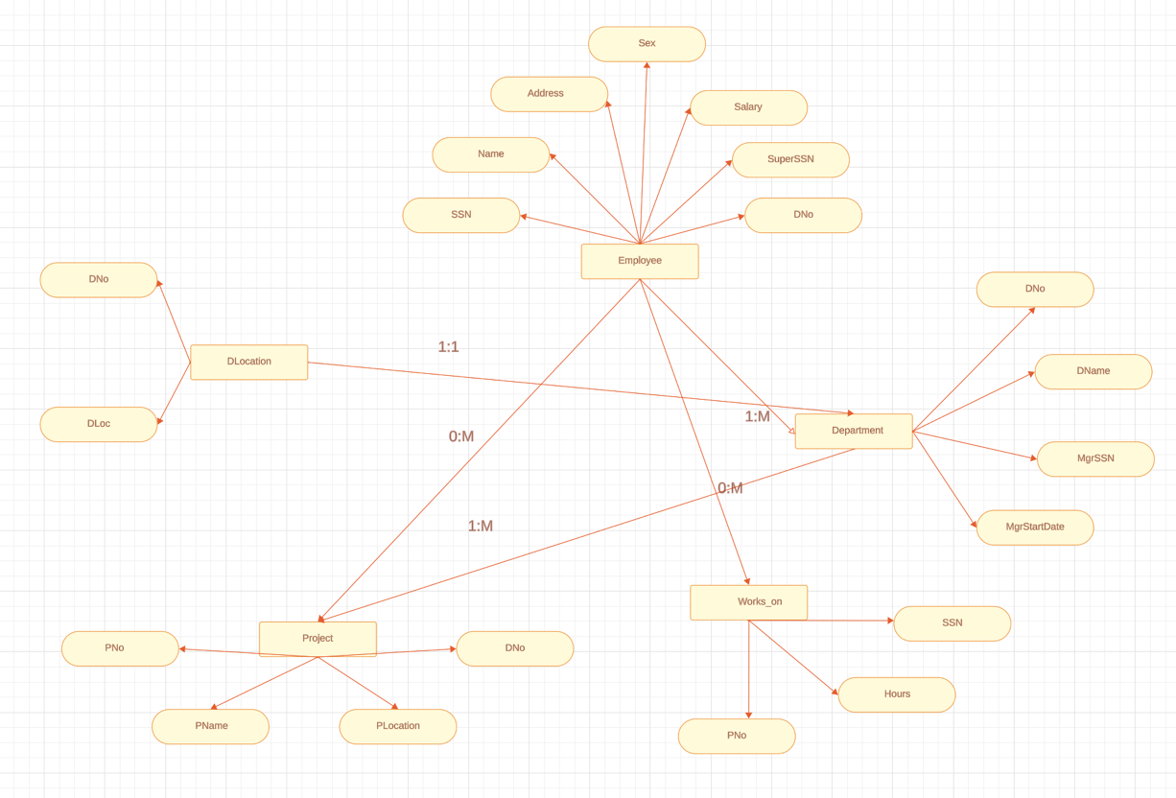

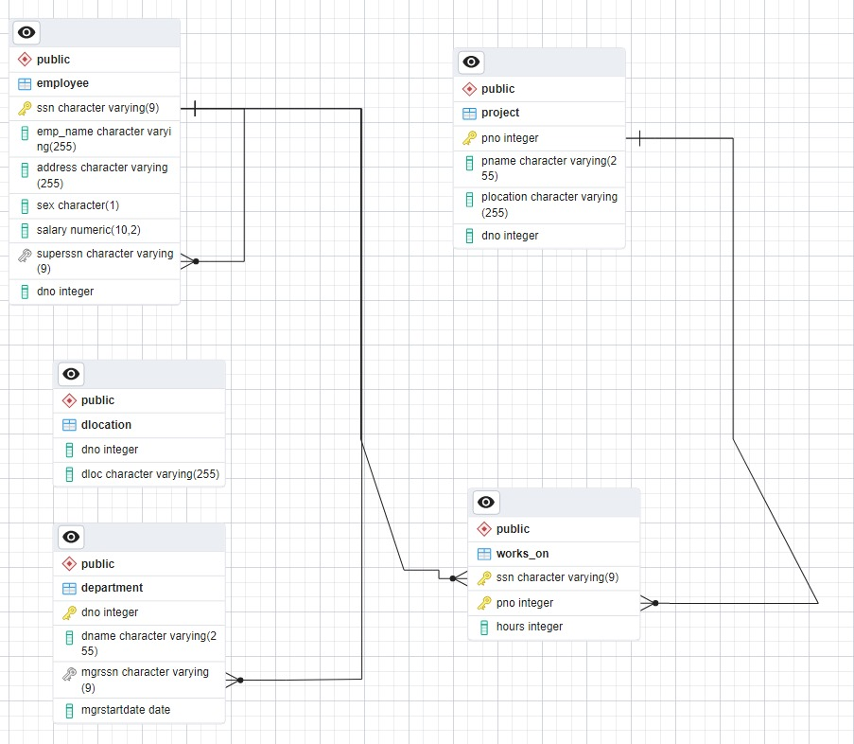

**Part II**

Consider the database for an organisation. Write the queries for the following (Schema of the tables depends on your creativity; Also include the fields and values mentioned in the question)

(i) Add 5 rows in the employee and dept tables

Employee Table:

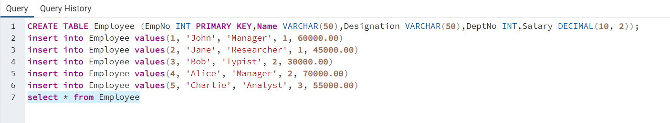

Dept Table:

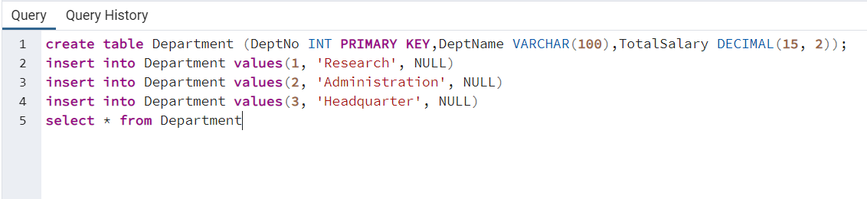

(ii) Display all the records from the above tables

Employee Table:

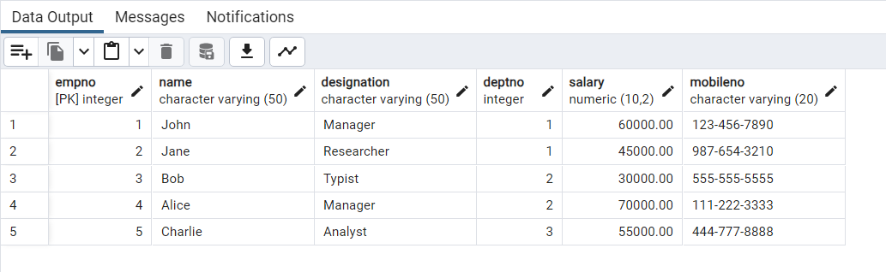

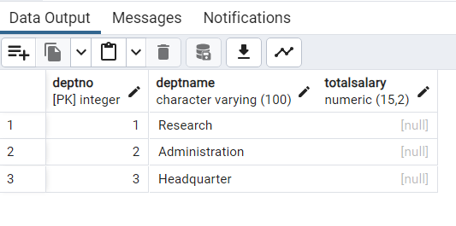

(iii) Display the empno and name of all the employees from department ‘Research’

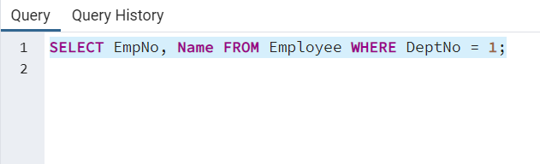

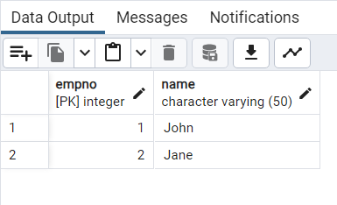

(iv) Display empno,name,designation,dept no and salary in the descending order of salary

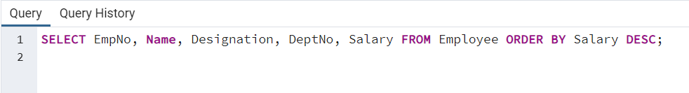

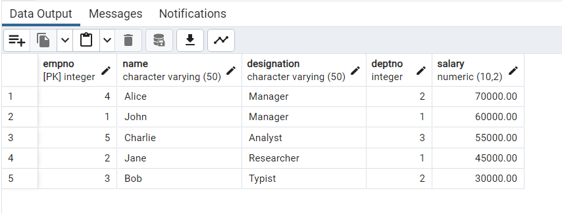

(v) Display the empno and name of all employees whose salary is between 20000 and 50000

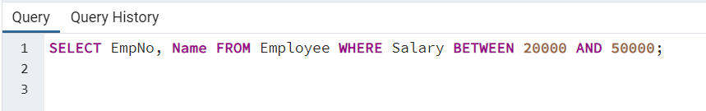

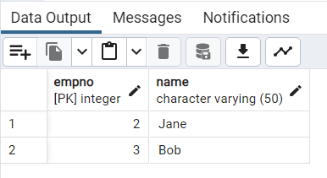

(vi) Display all designations without duplicate values.

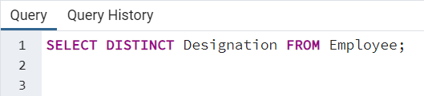

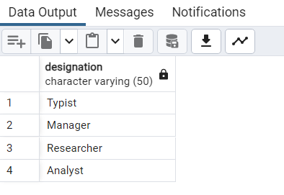

(vii) Display the dept name and total salary of employees of each department.

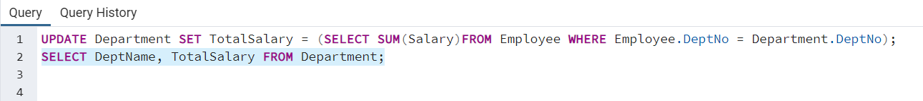

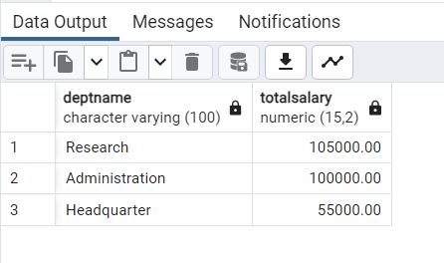

(viii) Change the salary of employees to 25000 whose designation is ‘Typist’

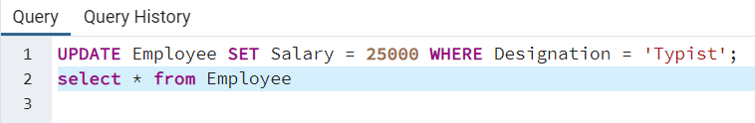

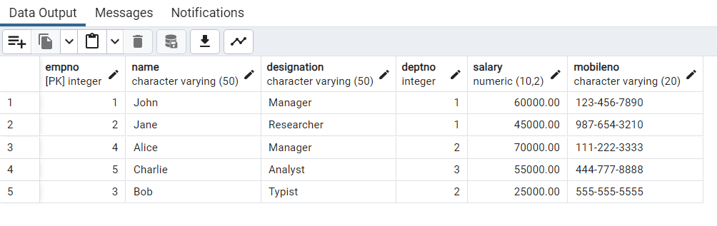

(ix) Change the mobile no of employee named ‘john’

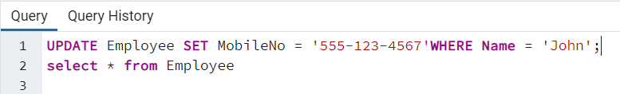

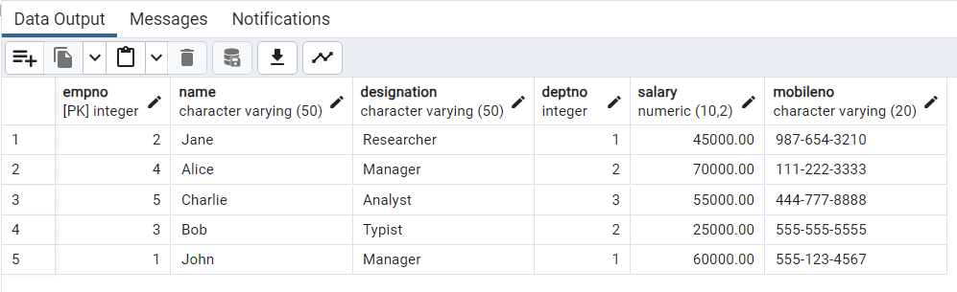

(x) Delete all employees whose salaries are equal to Rs.70000,; Select the department that has total salary paid for its employees more than 25000

